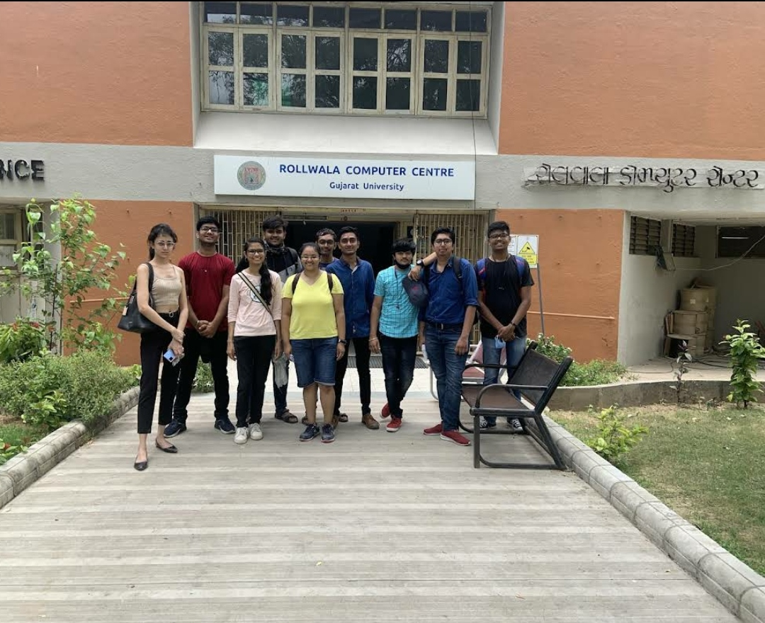

**Gujarat University**

**The Gujarat University was conceived in the nineteen twenties in the minds of public-spirited and learned men like Gandhiji, Sardar Patel, Acharya Anandshankar B. Dhruva, Dada Saheb Mavlankar, Kasturbhai Lalbhai and many others. However, the University could come into existence only after the achievement of independence.In 1949.**

### ★ DEPARTMENTS :

### 1) TECHNOLOGY :

### ● Animation IT-IMS & Mobile Applications

### ● Biochemistry & Forensic

### ● Botany, Bioinformatics And Climate Change

### ● Computer Science etc..

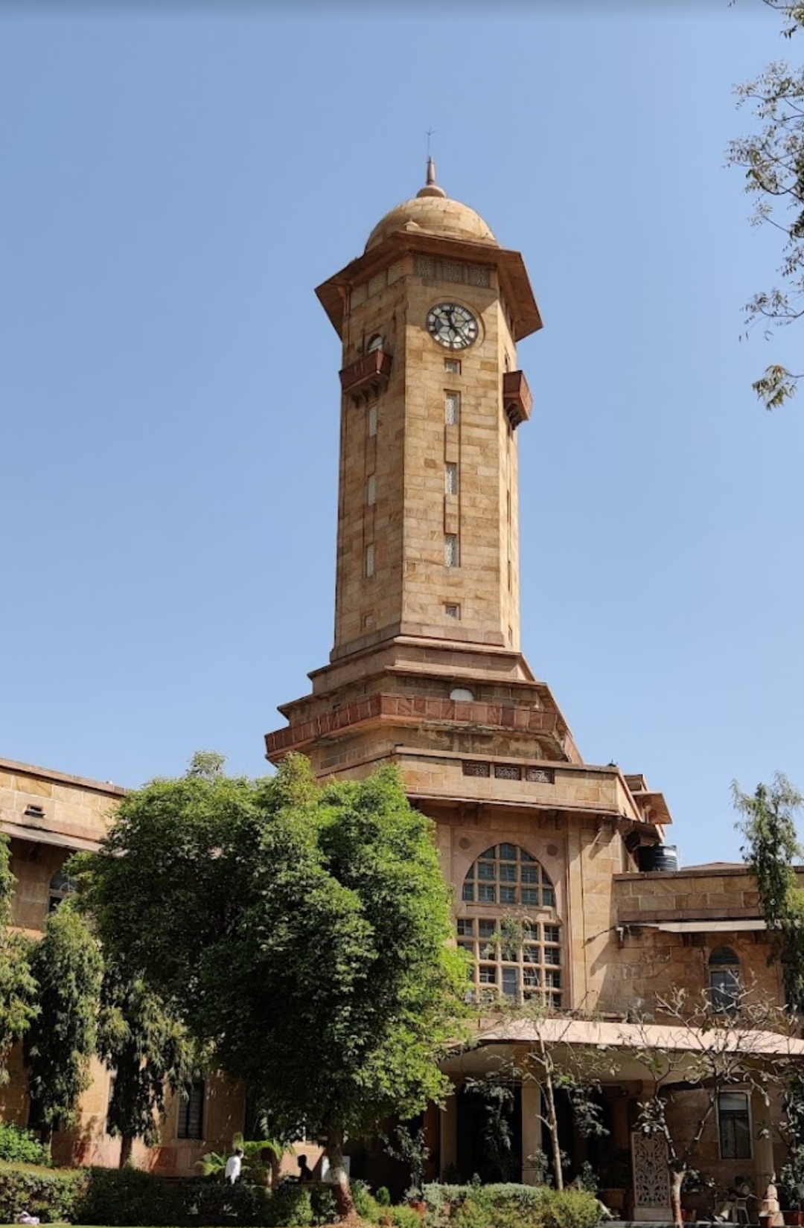

Rollwalla Computer Center

Introduction :

Rollwalla Computer Is Also Known As Department Of Computer Science . In This Place There Are Running So Many Cources Like ,

* M.Tech
* MCA
* MSc.Computer Science
* Msc. AI & ML